SUPPORT LATER START TIMES FOR HIGH SCHOOL STUDENTS
High School Students Need More Sleep: 9 hours
- Buses begin picking up students at 5:30 a.m. to meet 7:20 start times
- The nation’s top sleep researchers say: “Changes in sleep and circadian regulation occurring in adolescence are inconsistent with optimal learning when morning school start times are too early (before 8:30 or 9:00).”
- Sleep is critical to learning, especially the last REM sleep (which is cut short by early alarms).
- Driving while sleep-deprived is dangerous.
- Inadequate sleep is linked with increased depression, obesity, and diabetes.
The School Board’s Transportation Task Force (TTF) recommended that FCPS change bell schedules and improve system efficiency to enable later start times for high school students. The TTF Preferred Bell Schedule (ES/HS/MS) is:
- Most elementary schools would start 7:50-8:55; end 2:30-3:45 (Some still after 9 am)
- High schools would start between 8:35 and 8:55; end 3:15-3:45
- Middle schools would start between 9:20 and 9:40; end 4-4:30

The TTF expects its recommendations to be cost-neutral.
- No extra buses or drivers. Per FCPS, there is no longer a bus driver shortage.
- FCPS cost estimates continue to decrease as they model TTF recommendations.
- Reengineering and better use of technology can further increase efficiency and save money.
- Other schools have switched to later start times with no added costs: Arlington, VA; Minneapolis & Edina, MN; Wilton, CT; and Brevard, FL.; Albemarle, VA.
SLEEP endorses the TTF recommendations, which represent a compromise, and will advocate for reengineering to further decrease costs and improve bell times.

Others that support later start times for teens:
- Large majorities of parents, students and teachers, according to surveys
- Fairfax County Council of PTAs
- Virginia State PTA
- Student Advisory Committee to the Fairfax School Board
- Medical Society of Northern Virginia
- League of Women Voters of the Fairfax Area
- National Sleep Foundation
- Top sleep researchers in “Messages to the Public,” The Role of Sleep on Memory and Learning Conference, Washington, D.C., March 2008 (quoted above)
Support healthy start times and sign our petition at
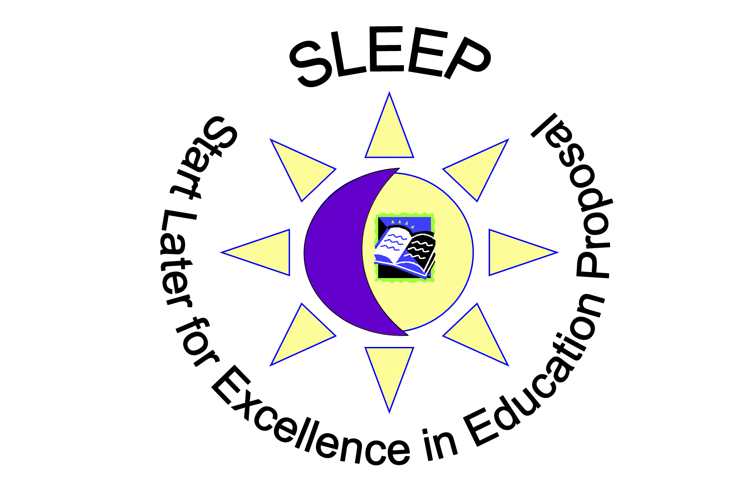
www.SLEEPINFAIRFAX.org

